**CONSTRUCTION OF WAREHOUSE CONCEPTS ON NORTH WIND DATABASE AS FOR PRODUCT SUPPLY CHAIN**

**By,**

**NAME: Vasireddy Hanish Sai**

**ID: 10402594**

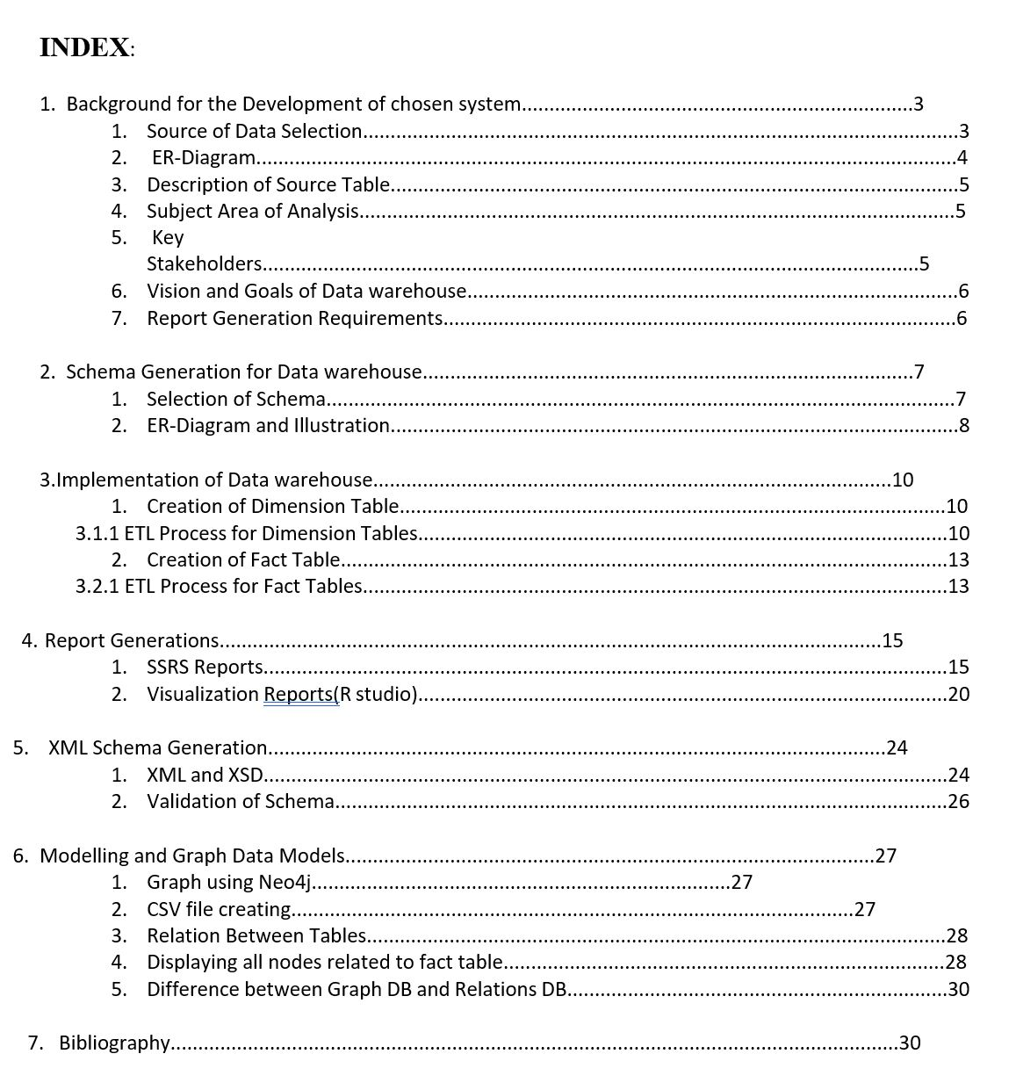

**1. Background for the Development of chosen system :**

When we are dealing with products we know that there exists a life cycle chain of products starting from the manufacturing and ending till it is received by the customers. Once an order is placed by the customer and the process that occurs till order is received is all maintained as a Supply chain process. For this we are using data warehousing concepts where we will store all the data related to this process and take only the data from which we can gather important information. Once we apply these concepts we can have reporting and visualisation by using different tools and technology.

* 1. Source of Data Selection:

We have selected Northwind database because it provides a very huge and accurate data related to the field we have chosen. We can directly get a sql file for complete installation of the data source in our SQL server. Once we have installed our database source then we can move ahead with warehouse creation.

* 1. ER-Diagram :

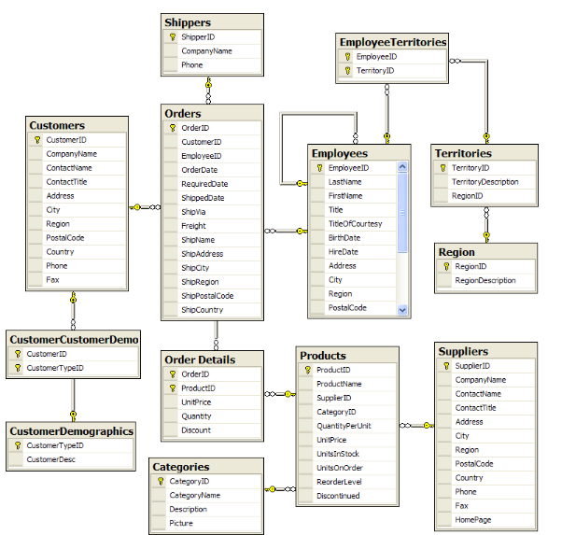

* 1. Description of Source Table :

The northwind source has these tables :

* Employee
* Customer
* Product
* Supplier
* Orders
  1. Subject Area of Analysis:

When we deal with supply chain we are mainly interested in the products and suppliers having those products, the way the order is shipped using different modes of shipping . When the order was placed and when did it reach. How many products were ordered and how much is left in the stock.

1.5 Key Stakeholders:

**The Key stakeholders are:**

* Employee
* Customer
* Product
* Supplier
* Orders

1.6 Vision and Goals of Data warehouse:

To keep track of complete product supply chain from manufacturing till delivery

Of the product to customers.

1.7 Report Generation Requirements:

**SSRS Report**

* Report for getting details of the product with the suppliers
* Report for seeing the Marginal difference between
* Report for seeing the shipping details of the order
* Report for showing the quantity per unit

**R Visualization**

* getting details of the product with the suppliers
* total transaction done for each product
* for seeing the shipping details of the order
* showing the quantity per unit

**2. Schema Generation for Data warehouse**

2.1 Selection of Schema:

To create database warehouse, we are opting star schema as it is easy to employee JOIN operation and to write WHERE clauses.

2.2 ER-Diagram and Illustration:

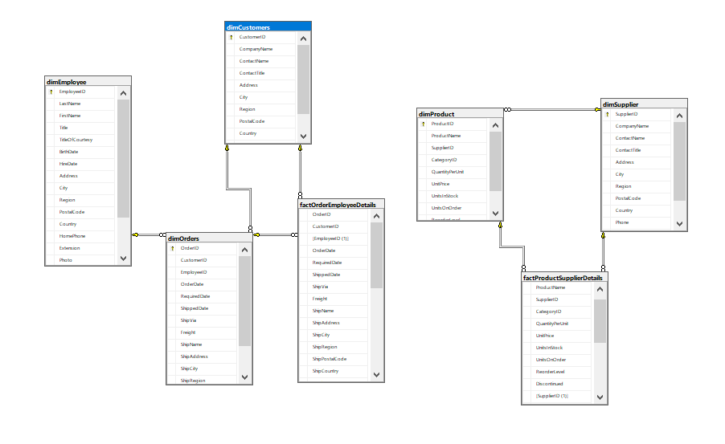

In above Star schema we have used six-dimensional table, named as follows

* dimCustomers- holds the details of customers.
* dimEmployee - holds the details of Employee.
* dimOrder - holds the details of Order.
* dimProduct- holds the details of product.
* dimSupplier - holds the details of Supplier.

**Two fact tables are as follows:**

* factOrderEmployeeDetails – Maintains the details of employee as well as the complete details of the Order.
* factProductsuppliersDetails – Maintains the details of the Product and those of suppliers taking care of it.

**3.IMPLIMENTATION OF DATA WARE HOUSE:**

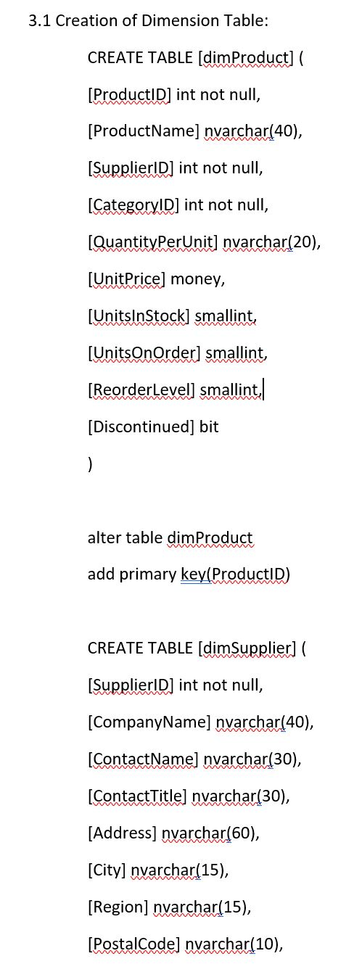

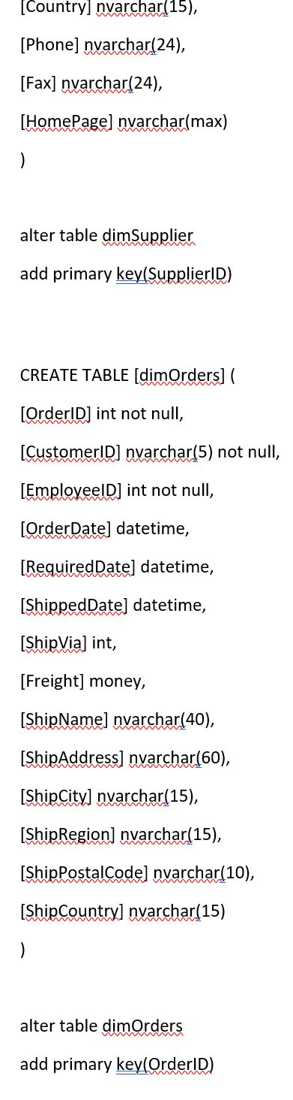

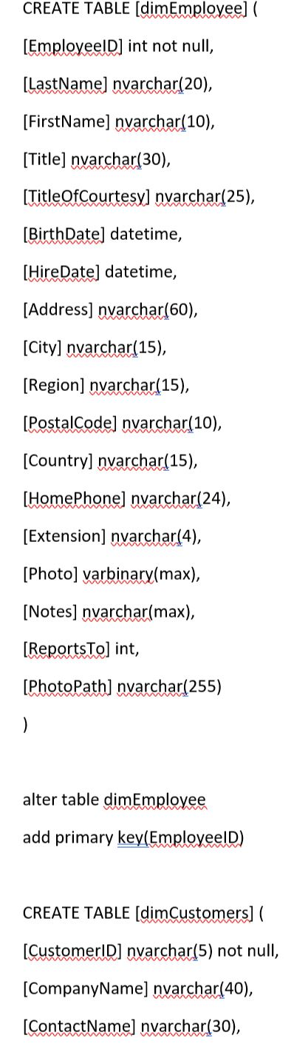

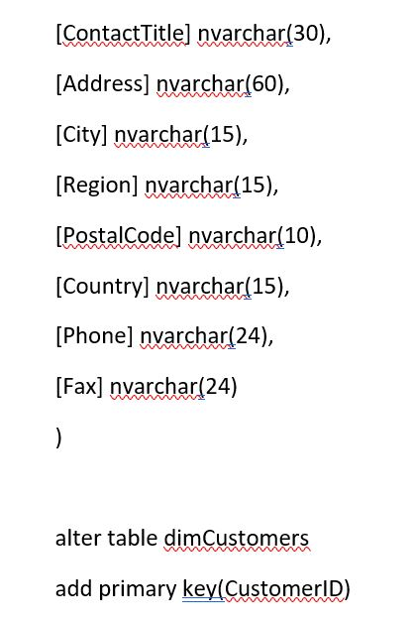

3.1.1 ETL Process for Dimension Tables:

In order to define the flow of data from our source data set to our newly created dimensional tables, we are setting forth SSIS packages.

--Creating package for dimCustomers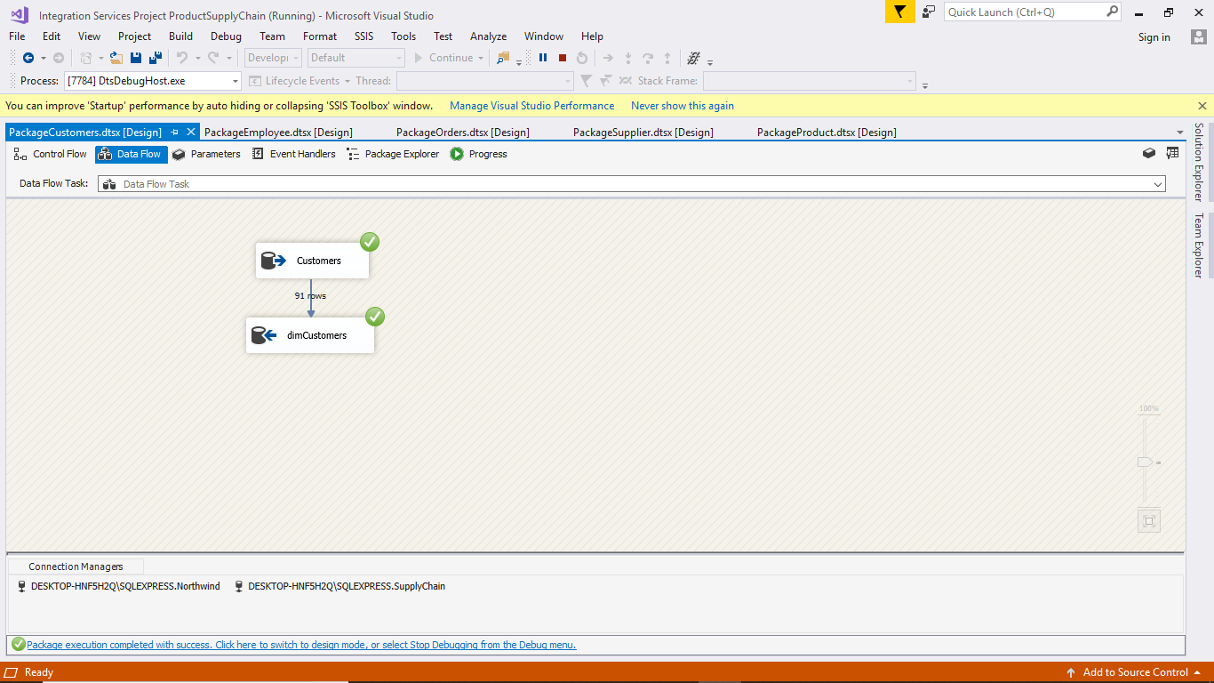

-- create package for dimEmployee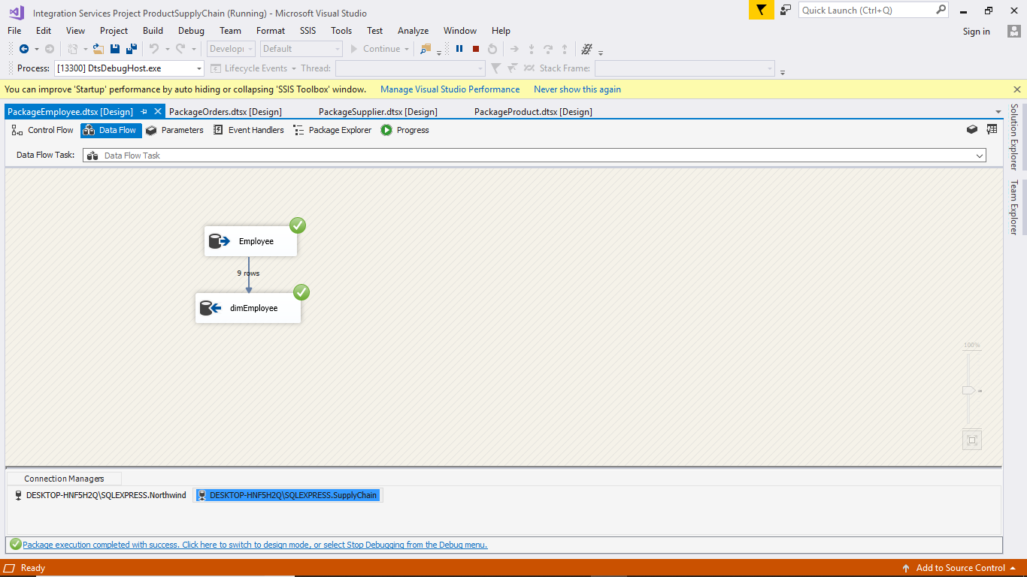

-- create package for  dimOrders

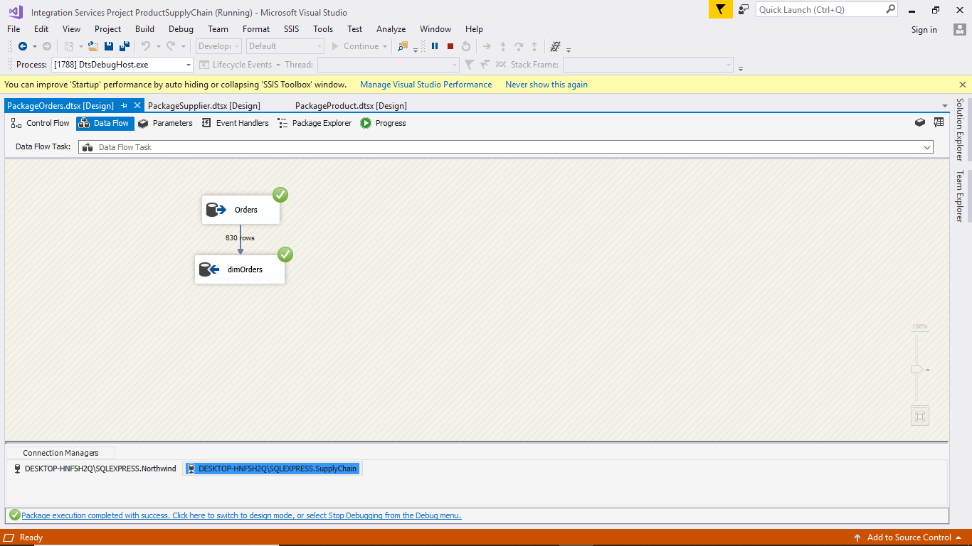

-- create package for dimProduct

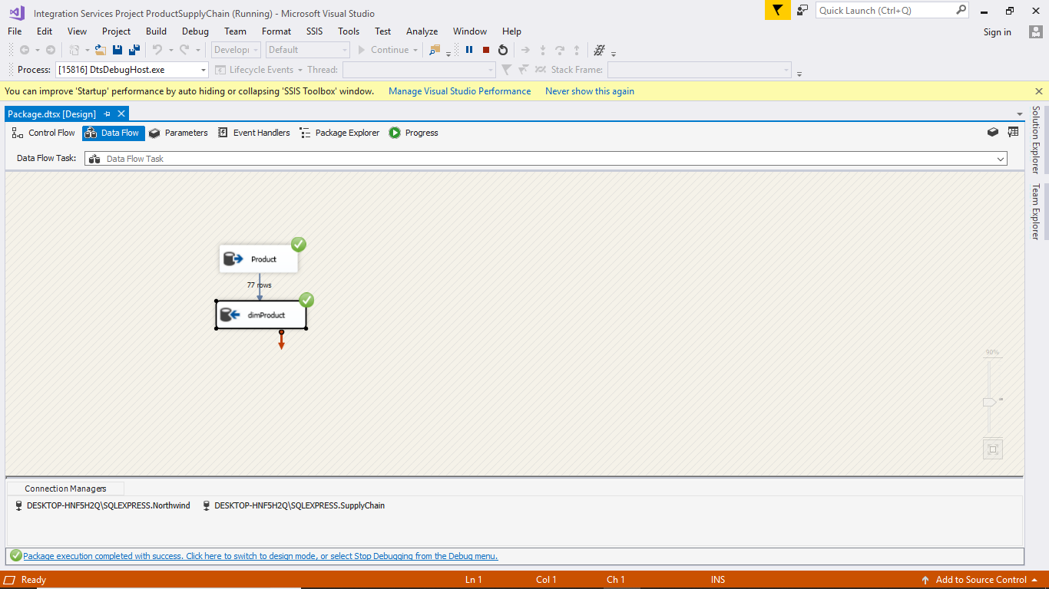

-- create package for dimSuppliers

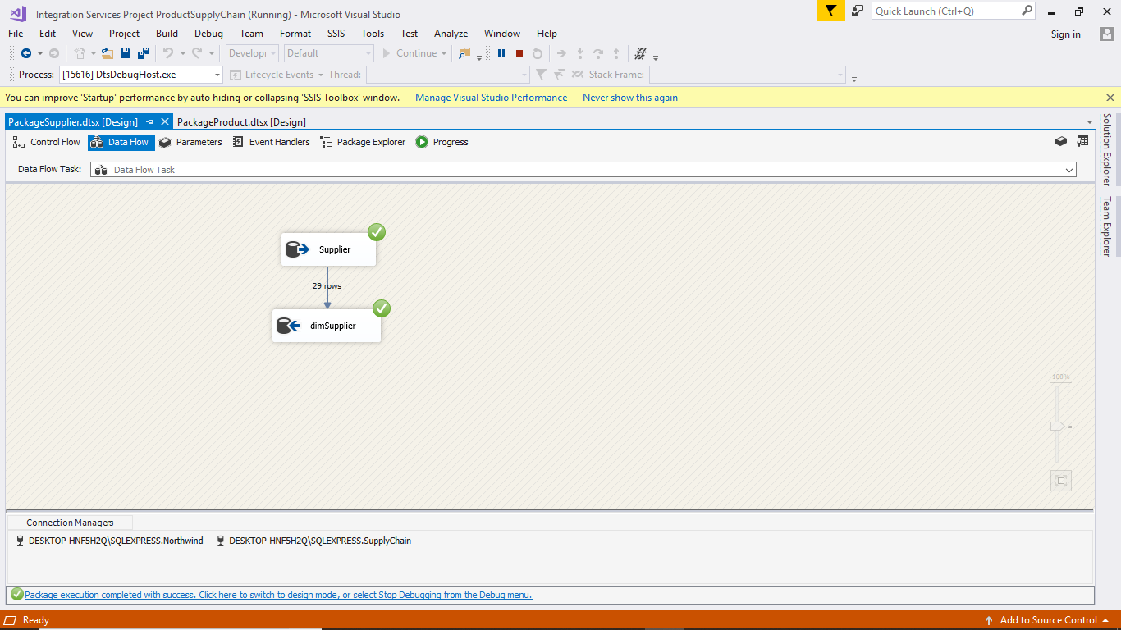

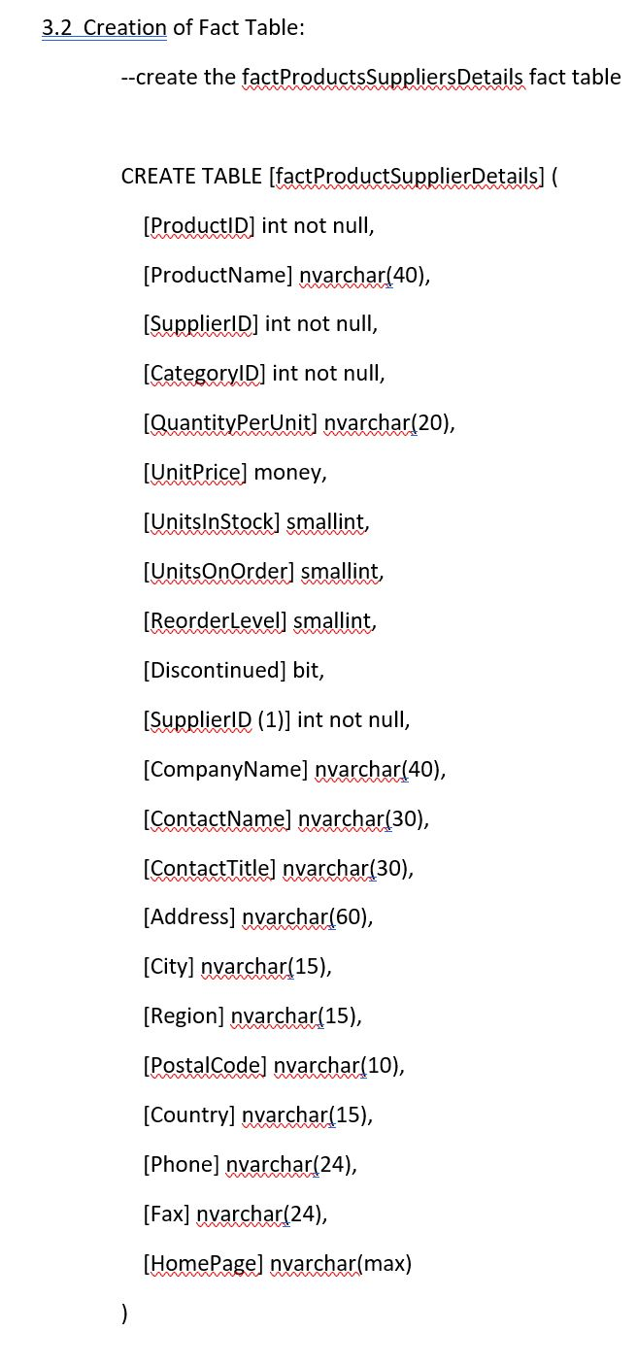

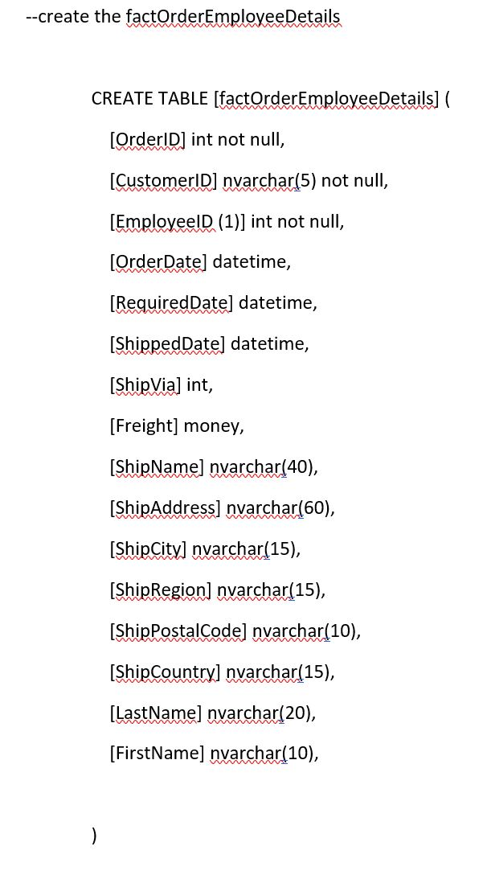

3.2.1 ETL Process for Fact Tables:

The packages for fact tables are built in which the data is intended to come from more than one dimensional table. So, the data from dimensional table is sorted and merged in to the fact table.

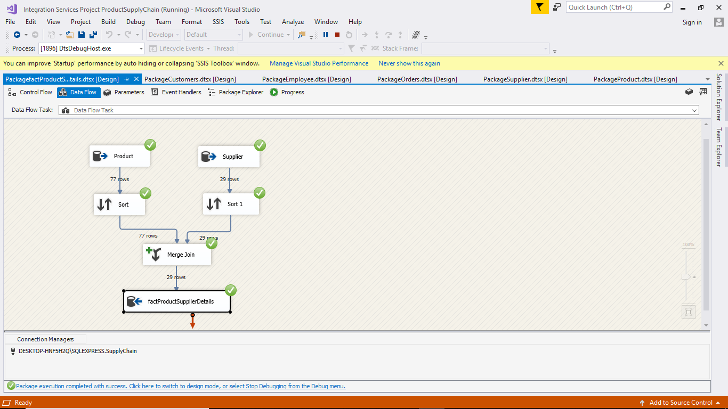

-- create package for  fact table factOrderEmployeeDetails

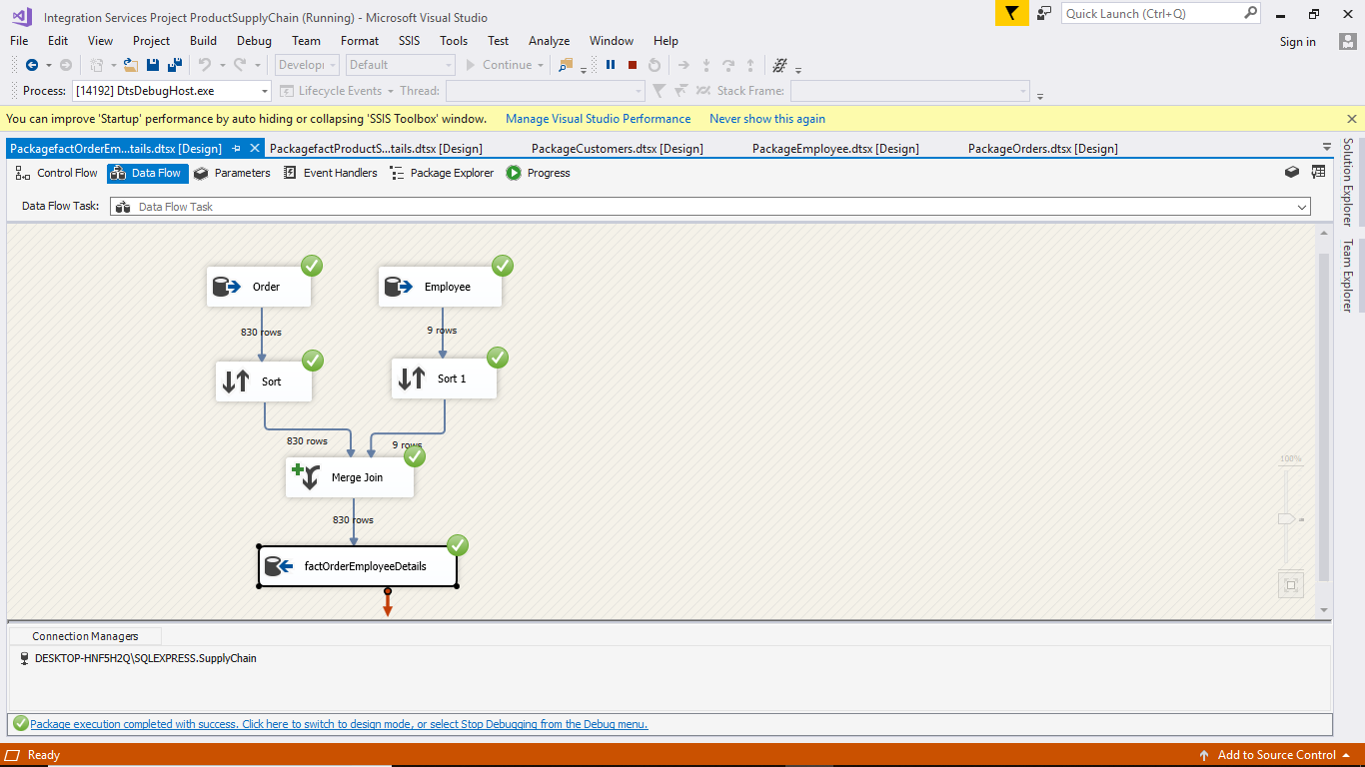

**4. REPORT GENARATION:**

**4.1 SSRS Reports:**

To outline the business statistics, reporting method is used where we employ warehousing in this specific area.

Report for getting details of the product with the suppliers-

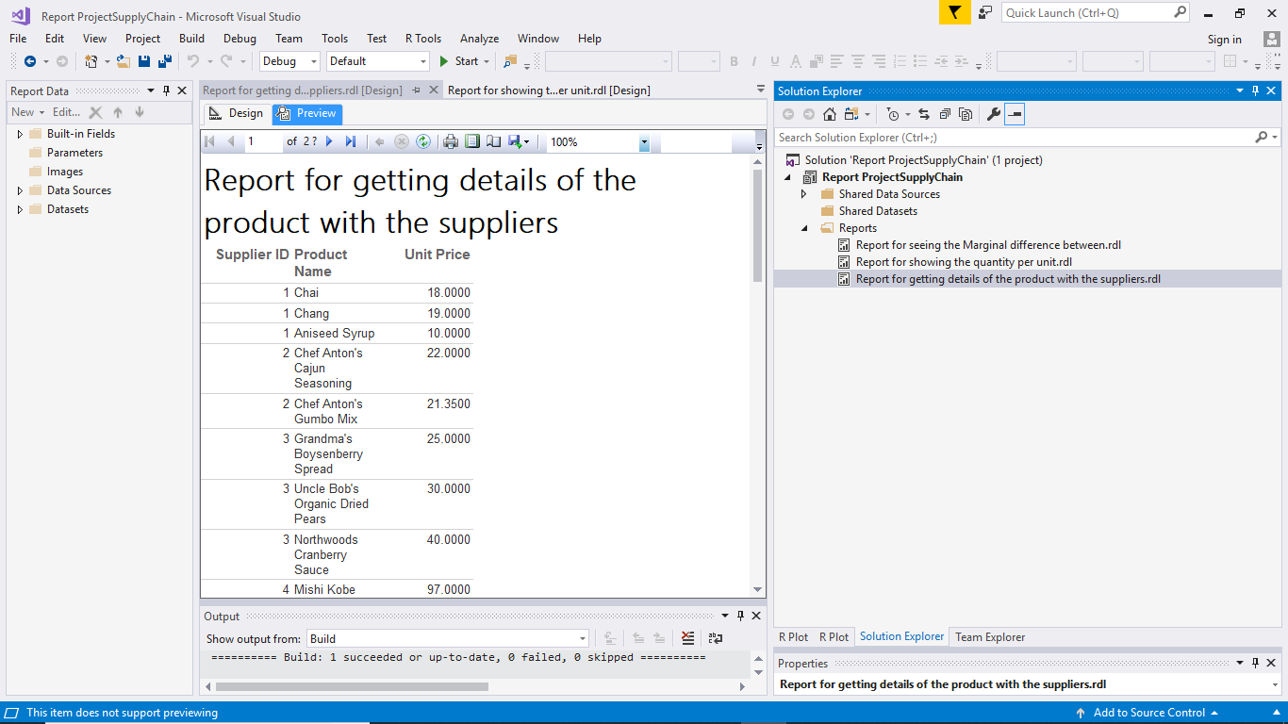

Report for seeing the Marginal difference between-

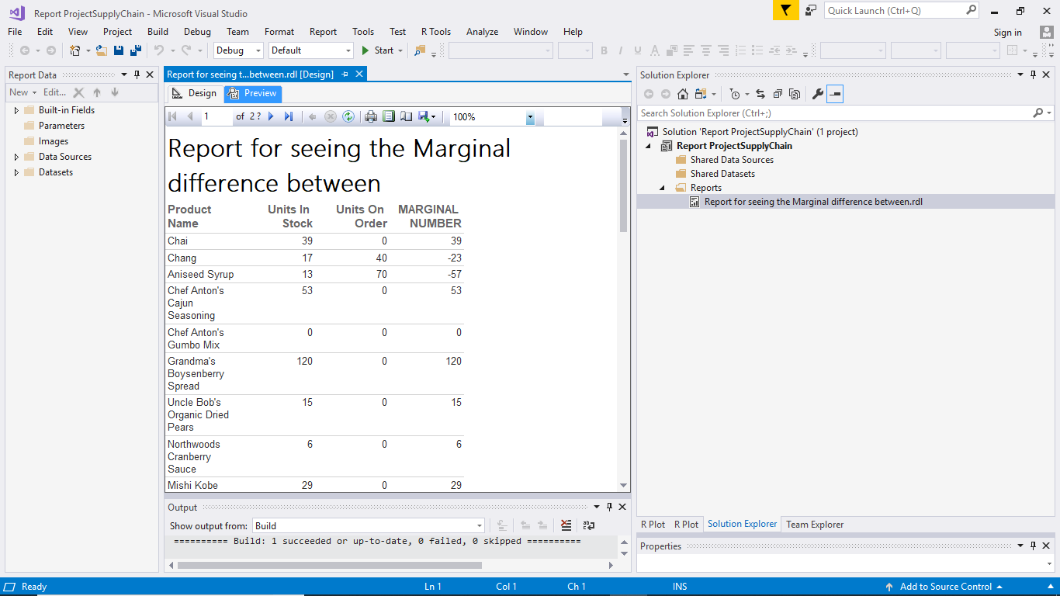

Report for showing the quantity per unit:

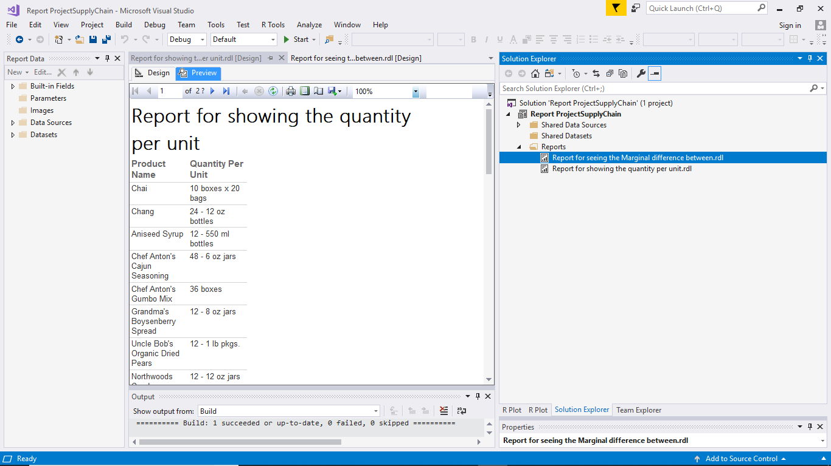

Report for seeing the shipping details of the order:

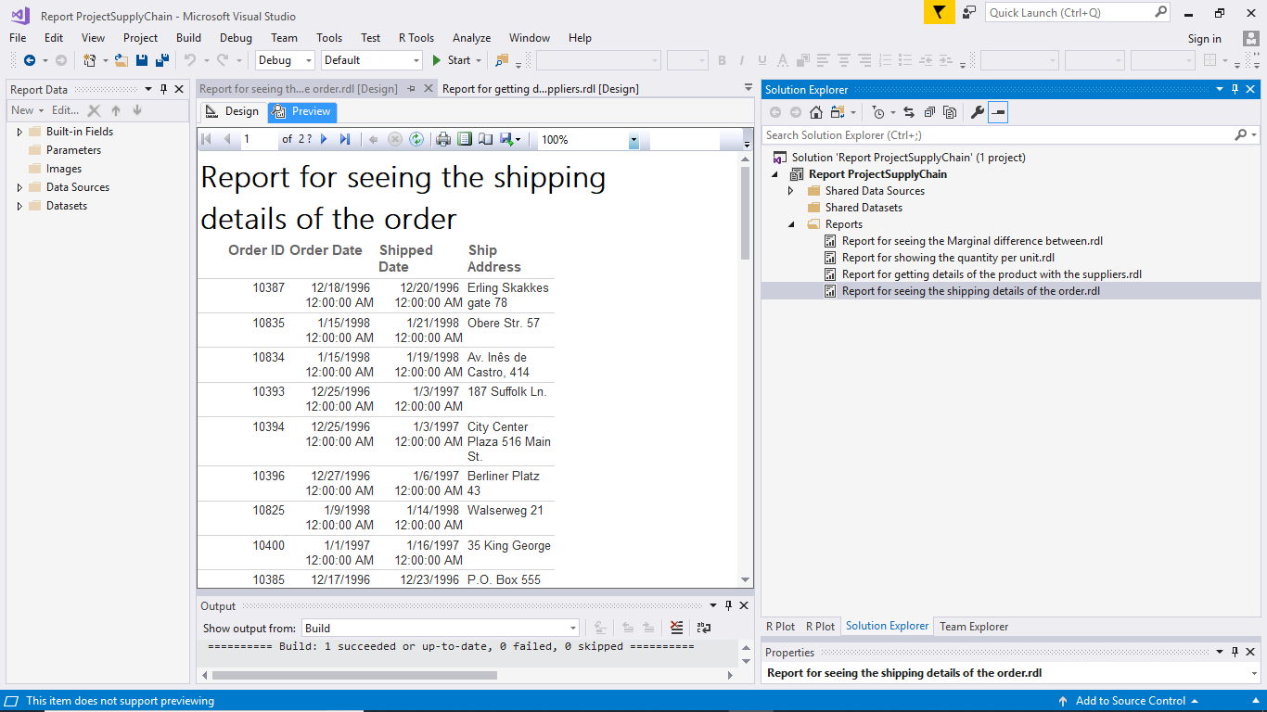

Using R tools we can visualize the data. We plot graphs on different data field values which we query from the data warehouse using the sql query in R language.

For visualising the Marginal value between ordered and the available stock of the product.

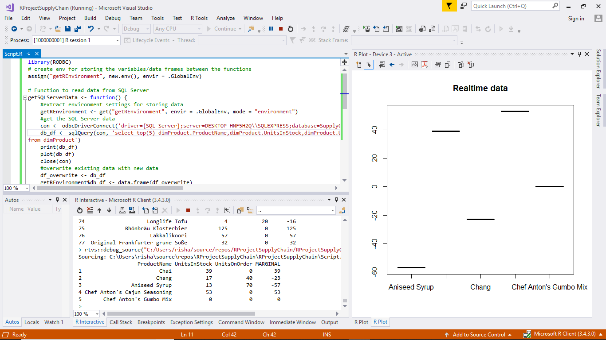

-- visualising the mode of shipping for the products.

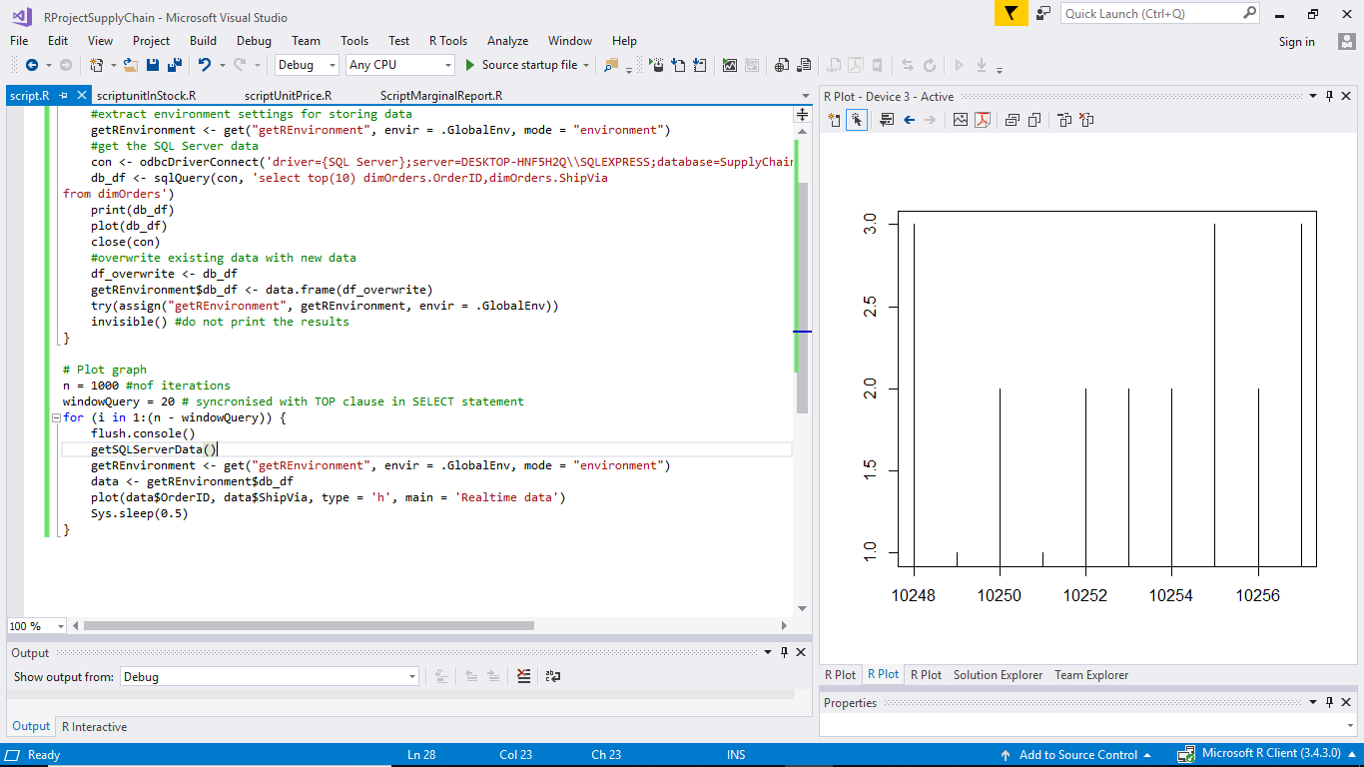

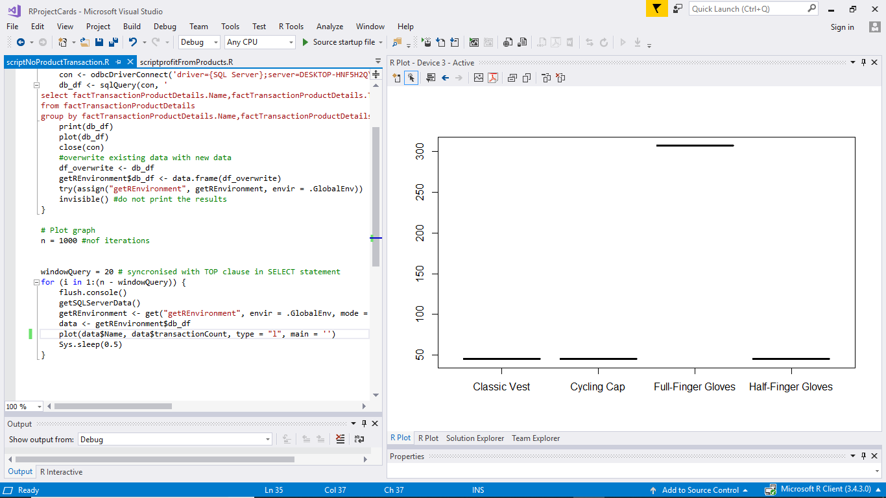

--visualising the unit price of each products.

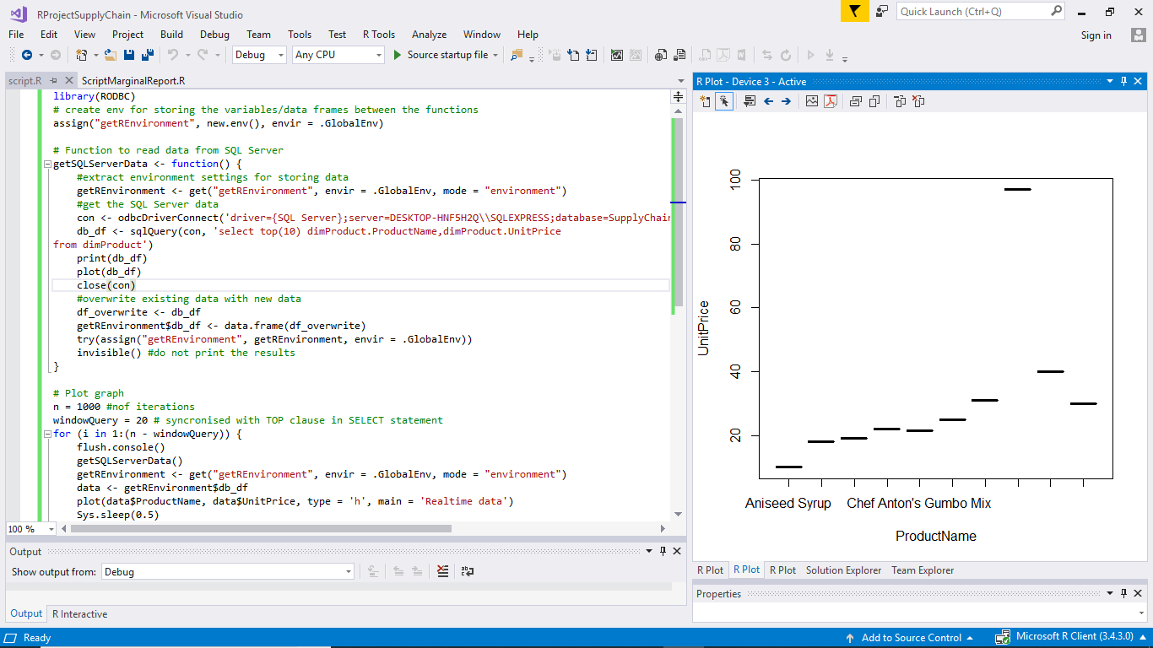

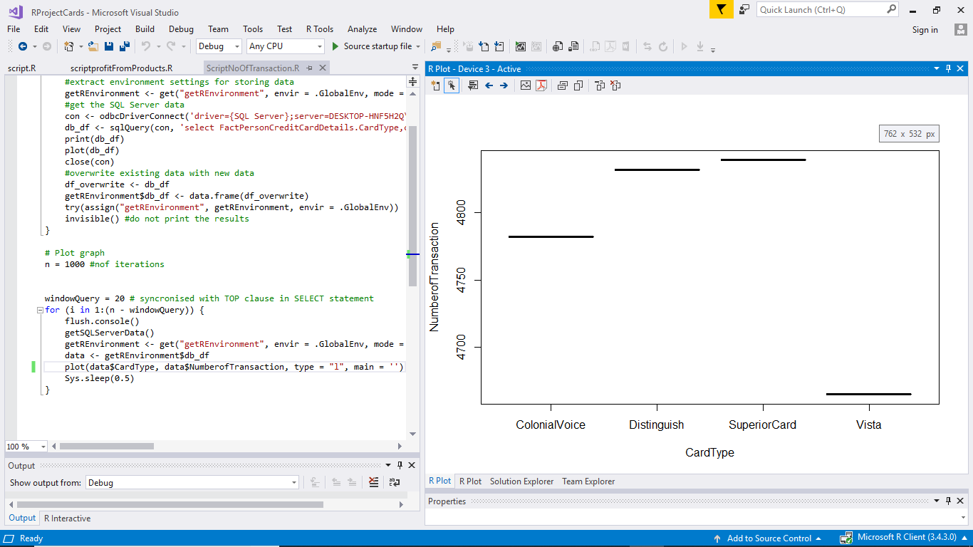

-- visualising the number of units in stock for each product

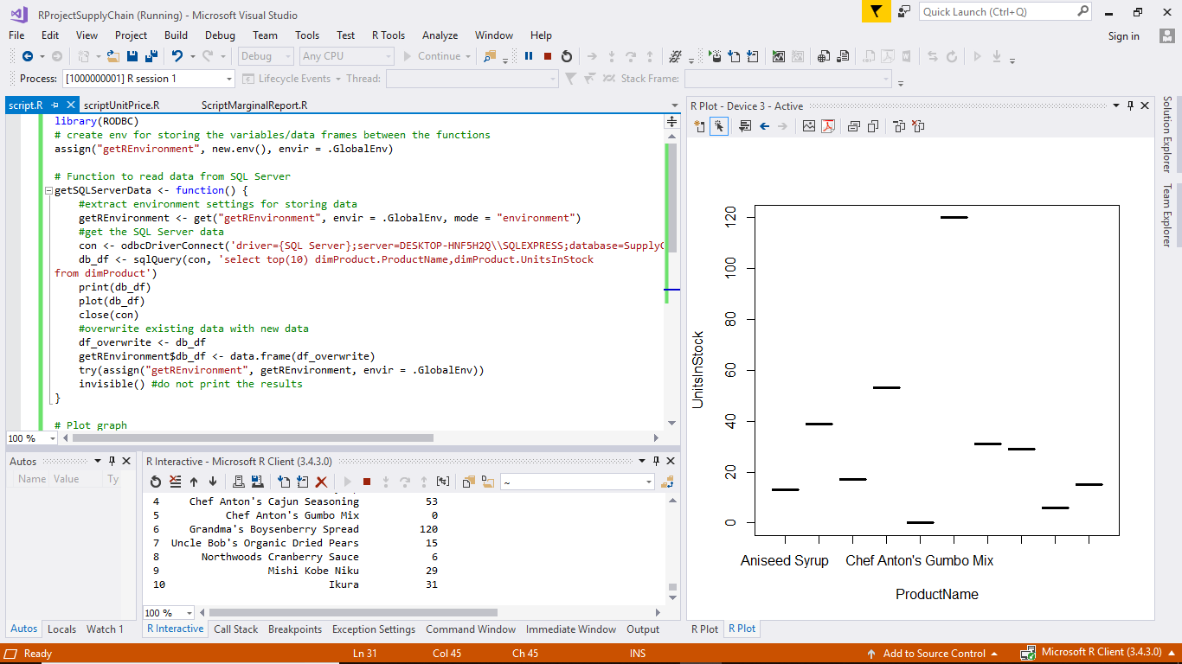

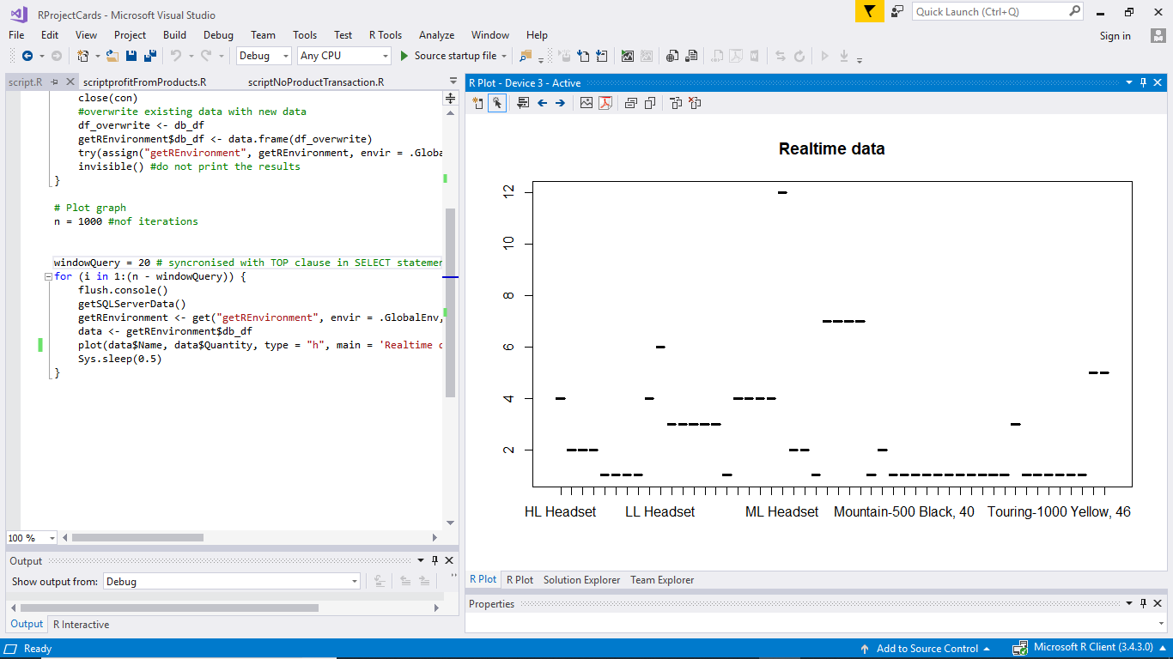

**5.  Extensible Markup Language Generation**

5.1 XML and XSD

To convert table data into XML data, we write stored procedure followed by the creation of XML schema using this XML data.

-- create XML Schema

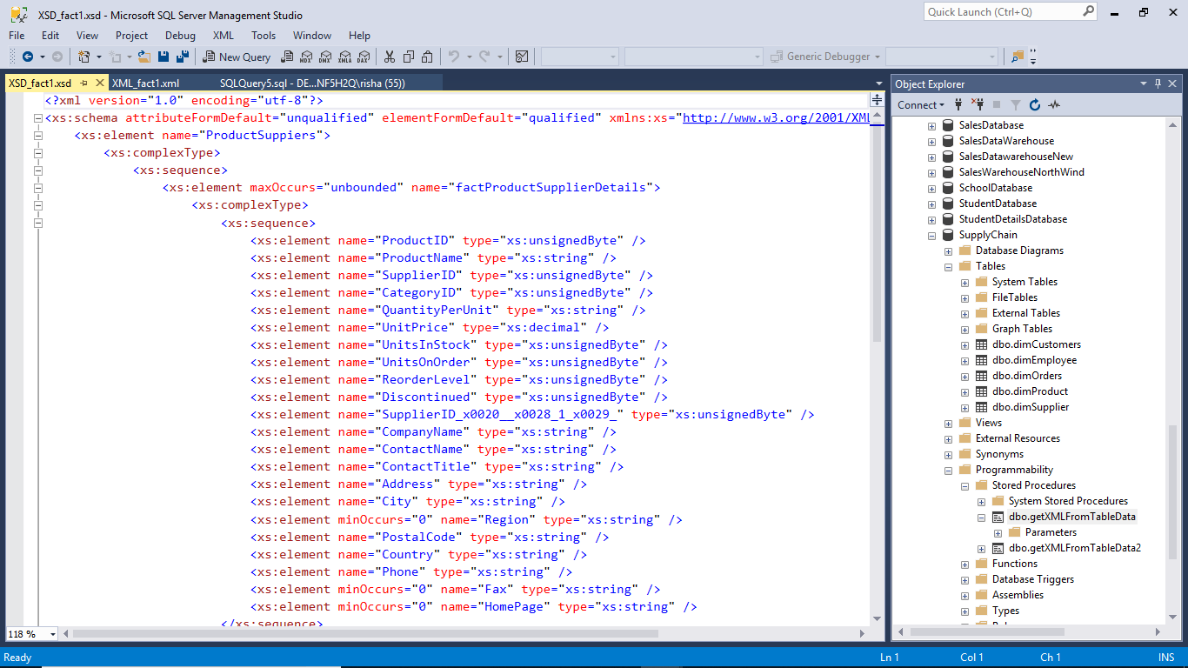

**--**XML schema fact2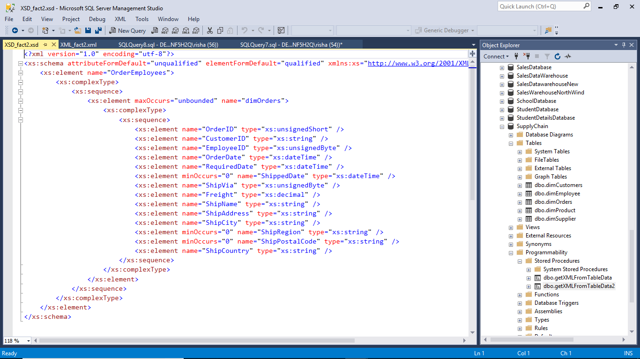

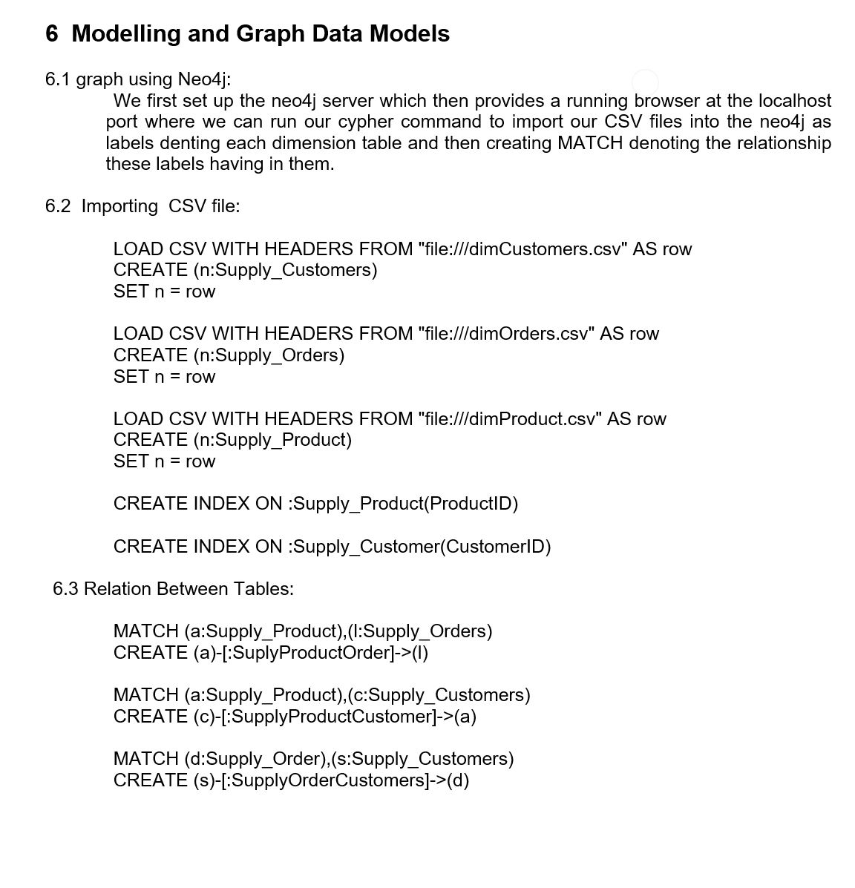

6.4  Displaying all nodes related to fact table:

To show relation between customers and the products.

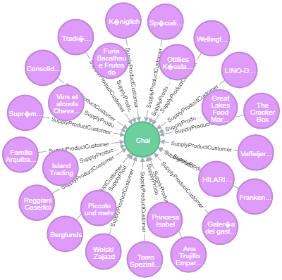

-- relation between the order and the products in the order.

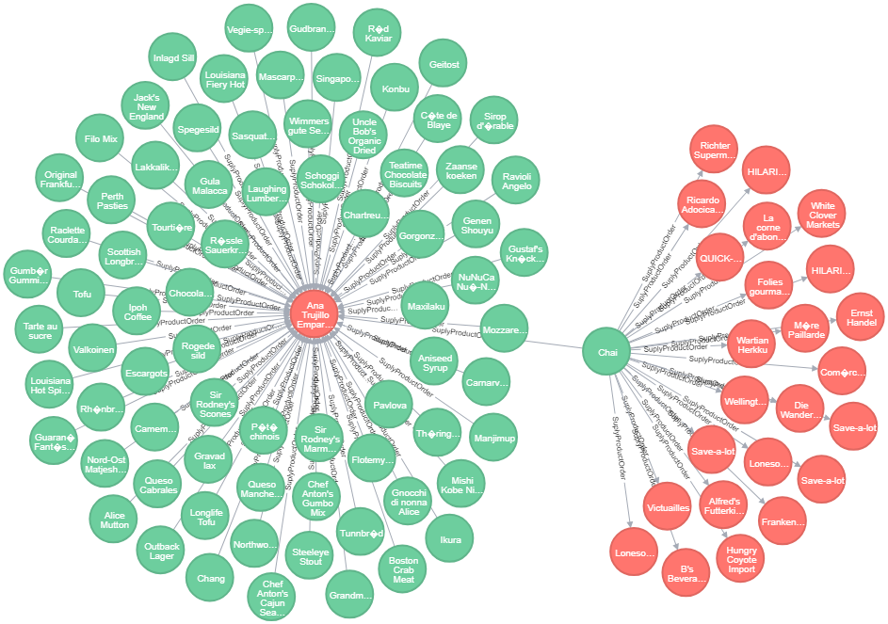

-- creating the graph for credit card details.

